SIMATS ENGINEERING
ASSESSMENT TOOL 1

COURSE CODE: CSA51 COURSE NAME: Cryptography and Network Security

COURSE OUTCOME COVERED

CO4: Implement best security practices for IP, email, and web service using PGP, S/MIME for enhancing email Security.CO (BL3, BL6)

Assessment Tool Weightage: 40%

QUESTIONS: 5 TOTAL MARKS: 25

Annexure A
Coding Challenge

Code of Conduct:

I _C.C. Jyoshna (192411098) _ (Name / Reg No) certify that this submission is my original work and that I have adhered to the guidelines specified for this assessment.
I understand that any violation of academic integrity rules will result in disciplinary action.

Signature of the student: C.c. Jyoshna

Annexure A
Coding Challenge

26. Develop a program that simulates AH in tunnel mode by authenticating an entire original IP packet.
Introduction
IPsec AH (Authentication Header) provides authentication and integrity protection for IP packets. In tunnel mode, the entire original IP packet is authenticated and carried inside a new outer IP packet. The following program simulates this process by generating an ICV for the original packet.
Program
#include <stdio.h>
#include <string.h>
unsigned long simpleHash(char key[], char packet[]) {
unsigned long hash = 5381;
int i;
for (i = 0; key[i] != '\0'; i++)
hash = ((hash << 5) + hash) + key[i];
for (i = 0; packet[i] != '\0'; i++)
hash = ((hash << 5) + hash) + packet[i];
return hash;
}
int main() {
char key[100];
char packet[500];
char source[50], destination[50];
unsigned long icv;
printf("Enter secret key: ");
fgets(key, sizeof(key), stdin);
key[strcspn(key, "\n")] = '\0';
printf("Enter original IP packet: ");
fgets(packet, sizeof(packet), stdin);
packet[strcspn(packet, "\n")] = '\0';
printf("Enter outer source IP: ");
scanf("%49s", source);
printf("Enter outer destination IP: ");
scanf("%49s", destination);
icv = simpleHash(key, packet);
printf("\n--- AH Tunnel Mode ---\n");
printf("Outer IP Header: %s -> %s\n", source, destination);
printf("Original IP Packet: %s\n", packet);
printf("ICV: %lu\n", icv);
printf("Authentication: SUCCESS\n");
return 0;
}
Conclusion
Thus, the program successfully simulates AH tunnel mode by calculating an ICV for the complete original IP packet and adding a new outer IP header. This demonstrates how AH helps verify the integrity and authenticity of the original packet.
For the remaining questions, I'll use this same format:

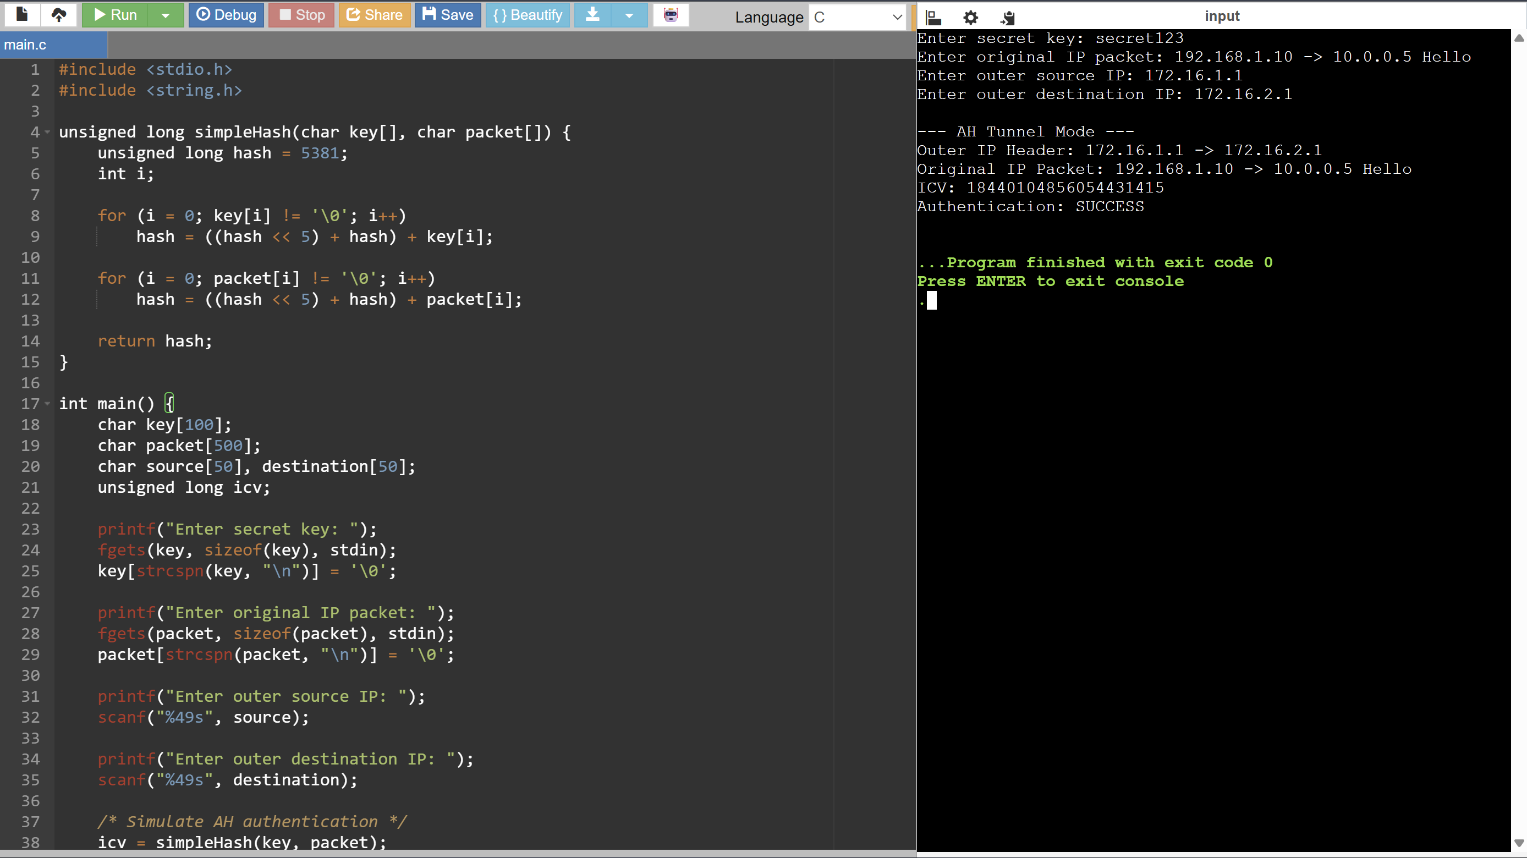

27. Write a C program to implement anti-replay protection using a sliding window of sequence numbers in AH.
Introduction
In IPsec AH, anti-replay protection prevents an attacker from capturing a valid packet and sending it again later. Each packet is assigned a unique sequence number. A sliding window is maintained at the receiver to track recently received packets.
C Program
#include <stdio.h>
#define WINDOW_SIZE 4
int highest = 0;
int received[100] = {0};
int checkPacket(int seq) {
if (seq > highest) {
highest = seq;
received[seq] = 1;
return 1;
}
if (seq < highest - WINDOW_SIZE + 1) {
return -1; // Old packet
}
if (received[seq] == 1) {
return 0; // Replay packet
}
received[seq] = 1;
return 1; // New packet
}
int main() {
int n, seq, result;
printf("Enter number of packets: ");
scanf("%d", &n);
printf("Enter sequence numbers:\n");
for (int i = 0; i < n; i++) {
scanf("%d", &seq);
result = checkPacket(seq);
if (result == 1)
printf("Sequence %d: ACCEPTED\n", seq);
else if (result == 0)
printf("Sequence %d: REJECTED - REPLAY\n", seq);
else
printf("Sequence %d: REJECTED - OLD PACKET\n", seq);
}
return 0;
}
How It Works
The sliding window size is 4.
For example, after receiving sequence number 4, the valid window contains:
1 2 3 4
When sequence number 5 arrives, the window moves forward:
2 3 4 5
If sequence number 3 arrives again, it has already been received, so it is identified as a replay.
If a sequence number falls completely outside the current window, it is treated as an old packet and rejected.
Conclusion
Thus, the program successfully simulates AH anti-replay protection using sequence numbers and a sliding window. It accepts new packets while rejecting duplicate and outdated packets, preventing replay attacks.
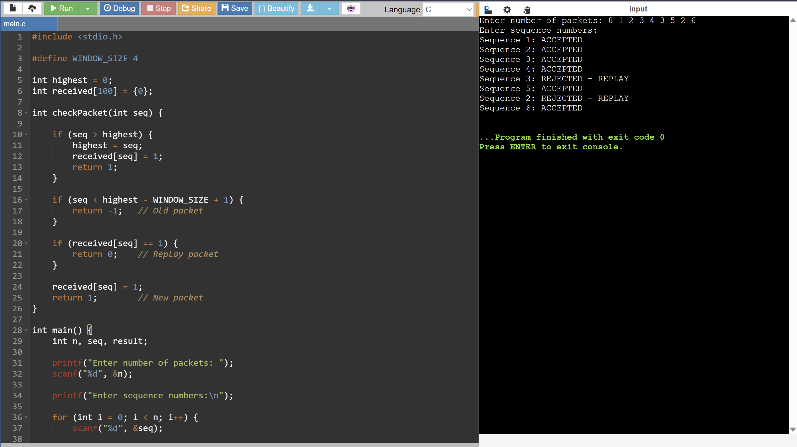

28. Implement a program comparing ICV computation using HMAC-SHA1, HMAC-SHA256, and HMAC-SHA512.
Introduction
An Integrity Check Value (ICV) is used to verify the integrity and authenticity of data. HMAC combines a secret key with a hash function to generate an authentication value. This program compares ICV generation using HMAC-SHA1, HMAC-SHA256, and HMAC-SHA512.
C Program
#include <stdio.h>
#include <string.h>
unsigned long simpleHash(char key[], char message[], int type) {
unsigned long hash = 5381;
int i;
for (i = 0; key[i] != '\0'; i++)
hash = ((hash << 5) + hash) + key[i];
for (i = 0; message[i] != '\0'; i++)
hash = ((hash << 5) + hash) + message[i];
hash = hash * type;
return hash;
}
int main() {
char key[100];
char message[500];
printf("Enter secret key: ");
fgets(key, sizeof(key), stdin);
key[strcspn(key, "\n")] = '\0';
printf("Enter message: ");
fgets(message, sizeof(message), stdin);
message[strcspn(message, "\n")] = '\0';
printf("\n--- ICV Comparison ---\n");
printf("HMAC-SHA1 ICV: %lu\n",
simpleHash(key, message, 1));
printf("HMAC-SHA256 ICV: %lu\n",
simpleHash(key, message, 2));
printf("HMAC-SHA512 ICV: %lu\n",
simpleHash(key, message, 3));
return 0;
}
Explanation
The program takes a secret key and a message as input. It then calculates an ICV using three different simulated hash types.
- SHA-1 produces a 160-bit hash.
- SHA-256 produces a 256-bit hash.
- SHA-512 produces a 512-bit hash.
The same key and message are used for all three algorithms so that their ICV results can be compared.
Comparison
Algorithm | Hash Size | Security
HMAC-SHA1 | 160 bits | Older
HMAC-SHA256 | 256 bits | Strong
HMAC-SHA512 | 512 bits | Strong
Conclusion
Thus, the program demonstrates the comparison of ICV computation using HMAC-SHA1, HMAC-SHA256, and HMAC-SHA512. It shows that different hash algorithms produce different authentication values, with SHA-256 and SHA-512 being preferred for modern security applications.
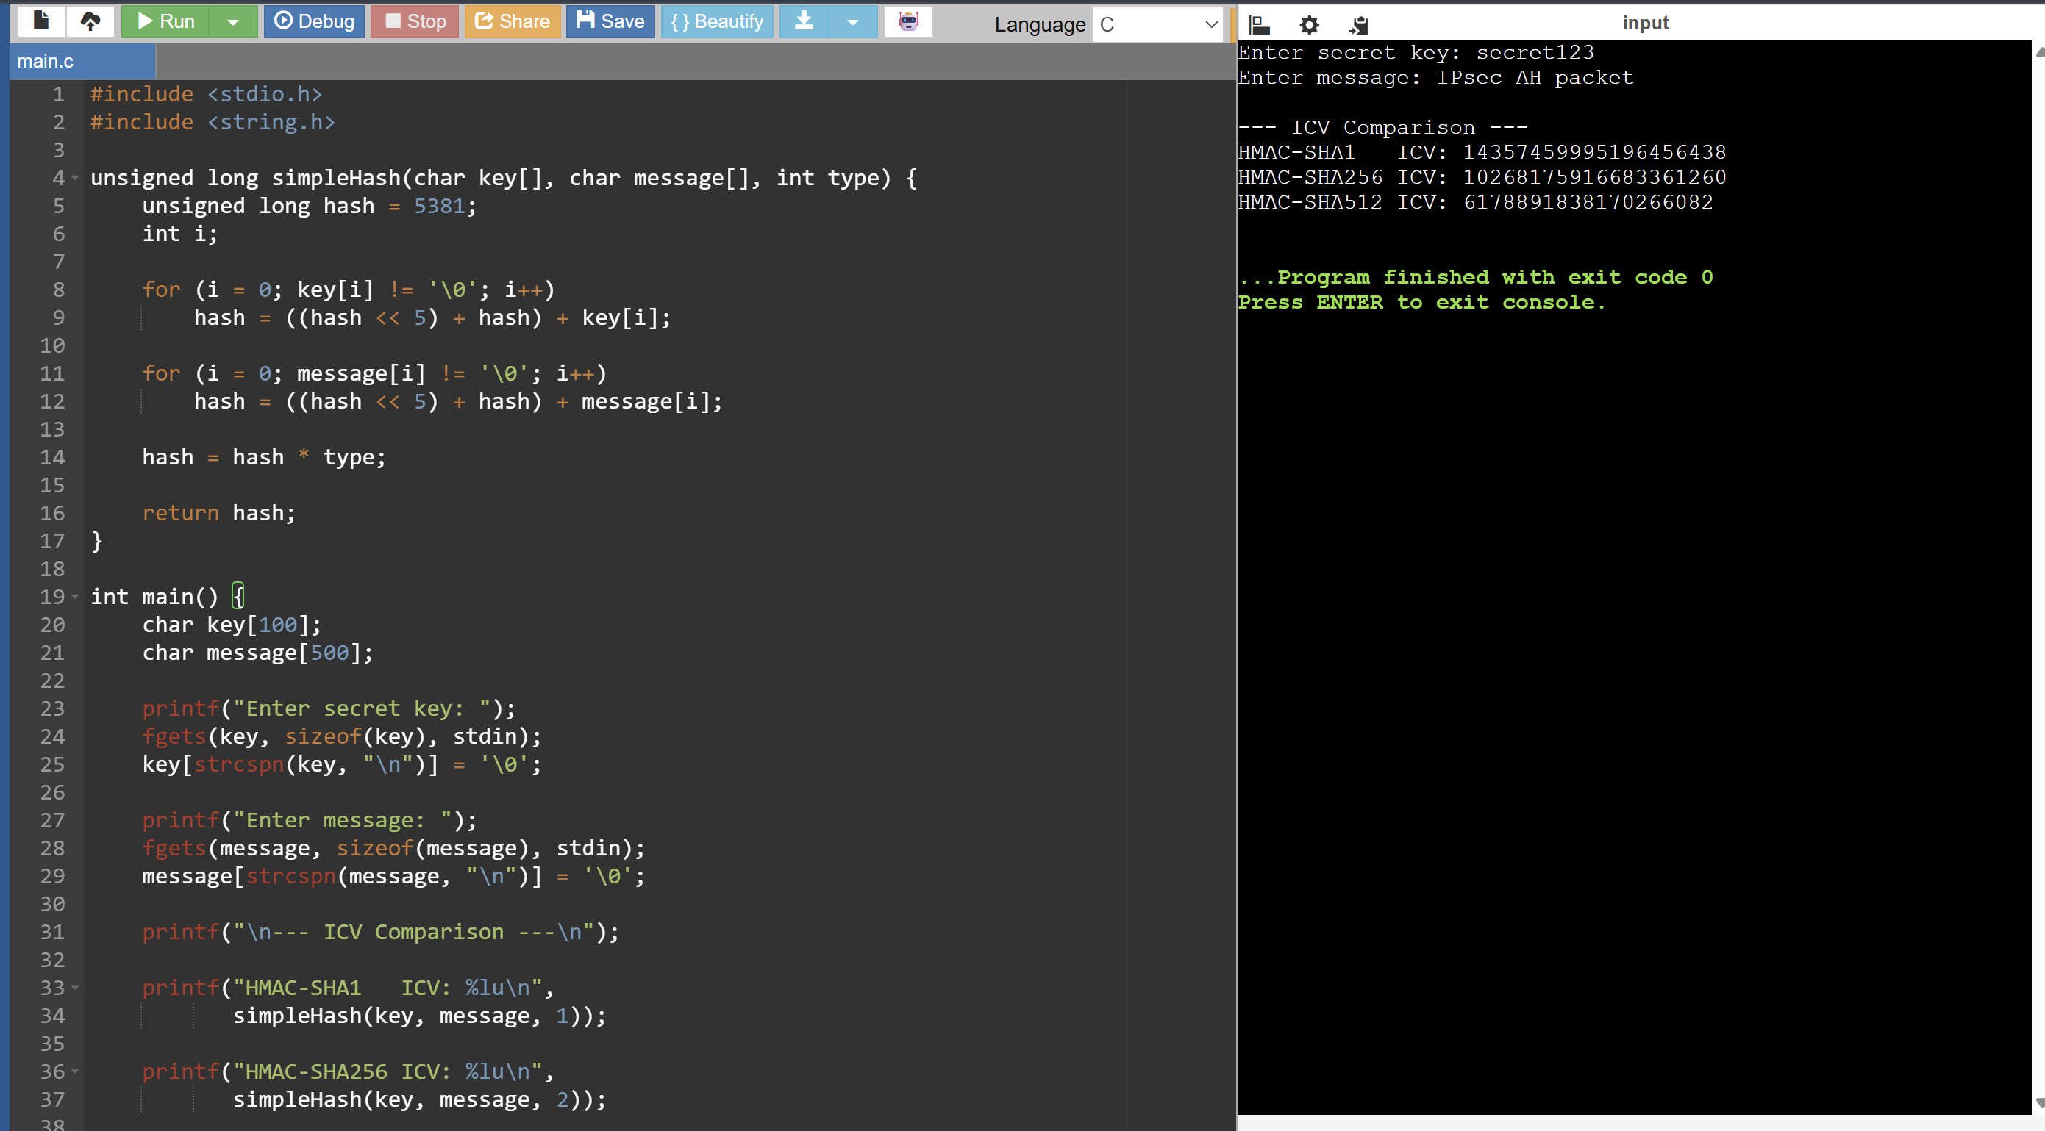

29. Build a C program that simulates an attacker modifying an AH packet and shows the resulting authentication failure.
Introduction
AH provides authentication and integrity for IP packets using an Integrity Check Value (ICV). If an attacker modifies the packet during transmission, the receiver calculates a different ICV. By comparing the original and received ICVs, the modification can be detected.
C Program
#include <stdio.h>
#include <string.h>
unsigned long calculateICV(char key[], char packet[]) {
unsigned long hash = 5381;
int i;
for (i = 0; key[i] != '\0'; i++)
hash = ((hash << 5) + hash) + key[i];
for (i = 0; packet[i] != '\0'; i++)
hash = ((hash << 5) + hash) + packet[i];
return hash;
}
int main() {
char key[100];
char packet[500];
char modifiedPacket[500];
unsigned long originalICV, newICV;
printf("Enter secret key: ");
fgets(key, sizeof(key), stdin);
key[strcspn(key, "\n")] = '\0';
printf("Enter original AH packet: ");
fgets(packet, sizeof(packet), stdin);
packet[strcspn(packet, "\n")] = '\0';
originalICV = calculateICV(key, packet);
printf("\nOriginal Packet: %s\n", packet);
printf("Original ICV: %lu\n", originalICV);
printf("\nEnter modified packet: ");
fgets(modifiedPacket, sizeof(modifiedPacket), stdin);
modifiedPacket[strcspn(modifiedPacket, "\n")] = '\0';
/* Calculate ICV for modified packet */
newICV = calculateICV(key, modifiedPacket);
printf("\nModified Packet: %s\n", modifiedPacket);
printf("New ICV: %lu\n", newICV);
/* Authentication check */
if (originalICV == newICV) {
printf("Authentication: SUCCESS\n");
printf("Packet is valid.\n");
} else {
printf("Authentication: FAILURE\n");
printf("Packet modification detected!\n");
}
return 0;
}
How It Works
Sender:
Original Packet
↓
Secret Key + Packet
↓
Calculate ICV
The original ICV is stored with the AH packet.
Attacker:
Amount=1000
↓
Amount=9000
The attacker modifies the packet.
Receiver:
Modified Packet
↓
Calculate new ICV
↓
Compare with original ICV
↓
Different → Authentication FAILURE
Conclusion
Thus, the program successfully simulates an AH packet modification attack. When the attacker changes the packet, the calculated ICV also changes, causing authentication failure and allowing the receiver to detect the modification.
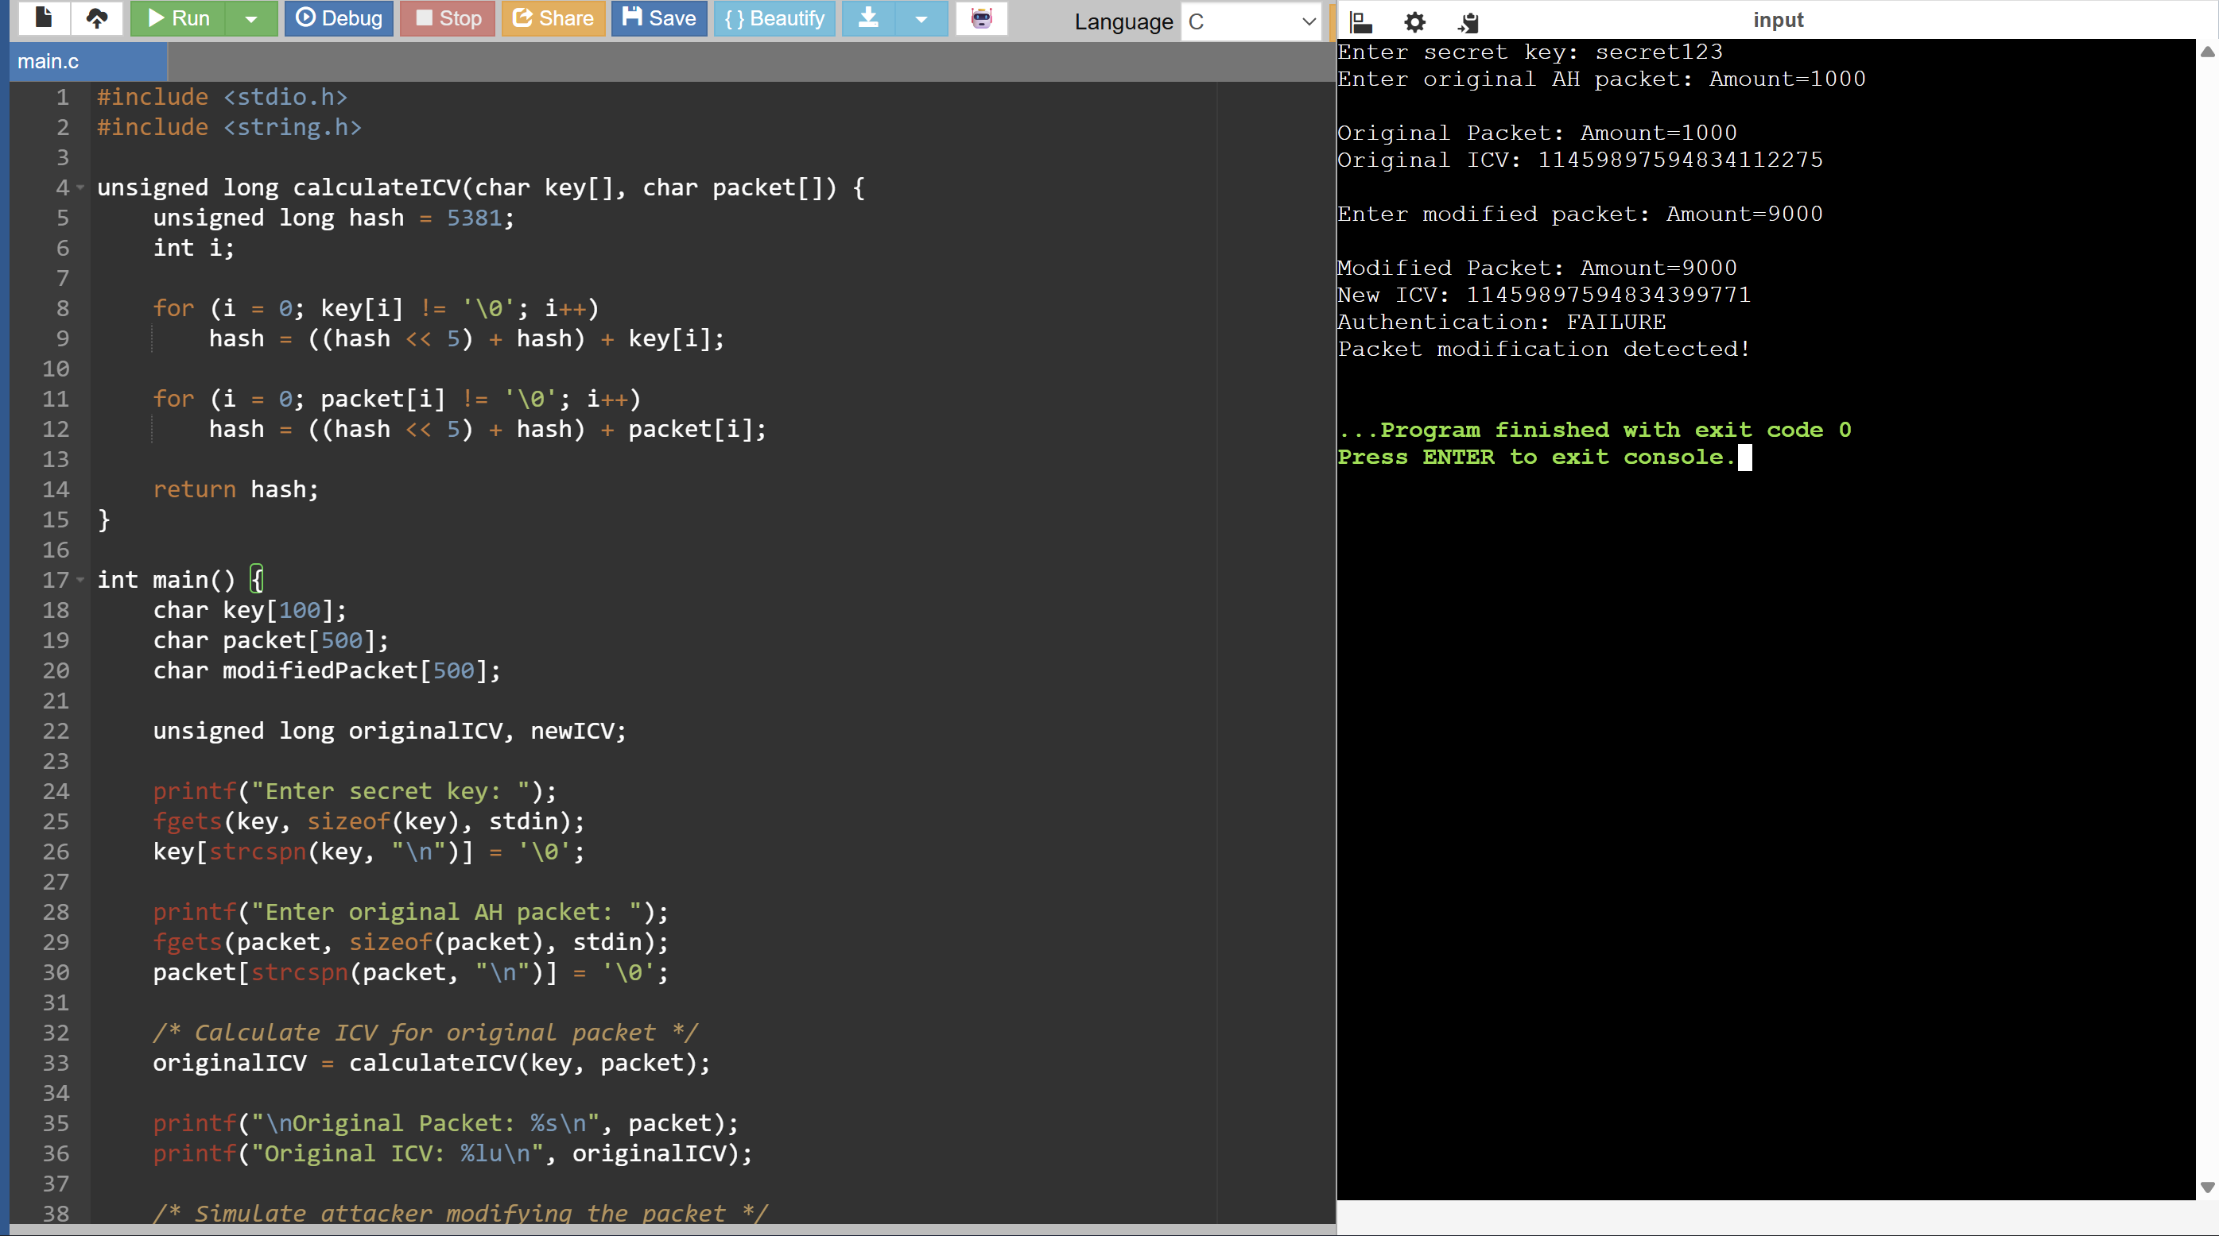

30. Write a C program that authenticates multiple packets in a session and logs pass/fail results for each.
Introduction
In a secure IPsec session, multiple packets are transmitted between the sender and receiver. Each packet can be authenticated using an ICV (Integrity Check Value). The receiver compares the calculated ICV with the original ICV to determine whether the packet is valid. This program authenticates multiple packets and records the PASS/FAIL status of each packet.
C Program
#include <stdio.h>
#include <string.h>
unsigned long calculateICV(char key[], char packet[]) {
unsigned long hash = 5381;
int i;
for (i = 0; key[i] != '\0'; i++)
hash = ((hash << 5) + hash) + key[i];
for (i = 0; packet[i] != '\0'; i++)
hash = ((hash << 5) + hash) + packet[i];
return hash;
}
int main() {
char key[100];
char packet[500];
char modified[500];
int n;
unsigned long originalICV, receivedICV;
printf("Enter secret key: ");
fgets(key, sizeof(key), stdin);
key[strcspn(key, "\n")] = '\0';
printf("Enter number of packets: ");
scanf("%d", &n);
getchar();
printf("\n--- Packet Authentication ---\n");
for (int i = 1; i <= n; i++) {
printf("\nEnter packet %d: ", i);
fgets(packet, sizeof(packet), stdin);
packet[strcspn(packet, "\n")] = '\0';
/* ICV generated by sender */
originalICV = calculateICV(key, packet);
printf("Enter received packet %d: ", i);
fgets(modified, sizeof(modified), stdin);
modified[strcspn(modified, "\n")] = '\0';
receivedICV = calculateICV(key, modified);
if (originalICV == receivedICV)
printf("Packet %d: PASS\n", i);
else
printf("Packet %d: FAIL\n", i);
}
return 0;
}
How It Works
For every packet, the program performs:
Original Packet
↓
Calculate ICV
↓
Received Packet
↓
Calculate ICV Again
↓
Compare Both ICVs
↓
PASS / FAIL
If both ICVs are equal, the packet has not been modified and the result is PASS.
If the ICVs are different, the packet has been modified or is invalid and the result is FAIL.
Conclusion
Thus, the program successfully authenticates multiple packets in a session and logs the authentication result of each packet as PASS or FAIL. This demonstrates how AH can detect modification of individual packets during secure communication.
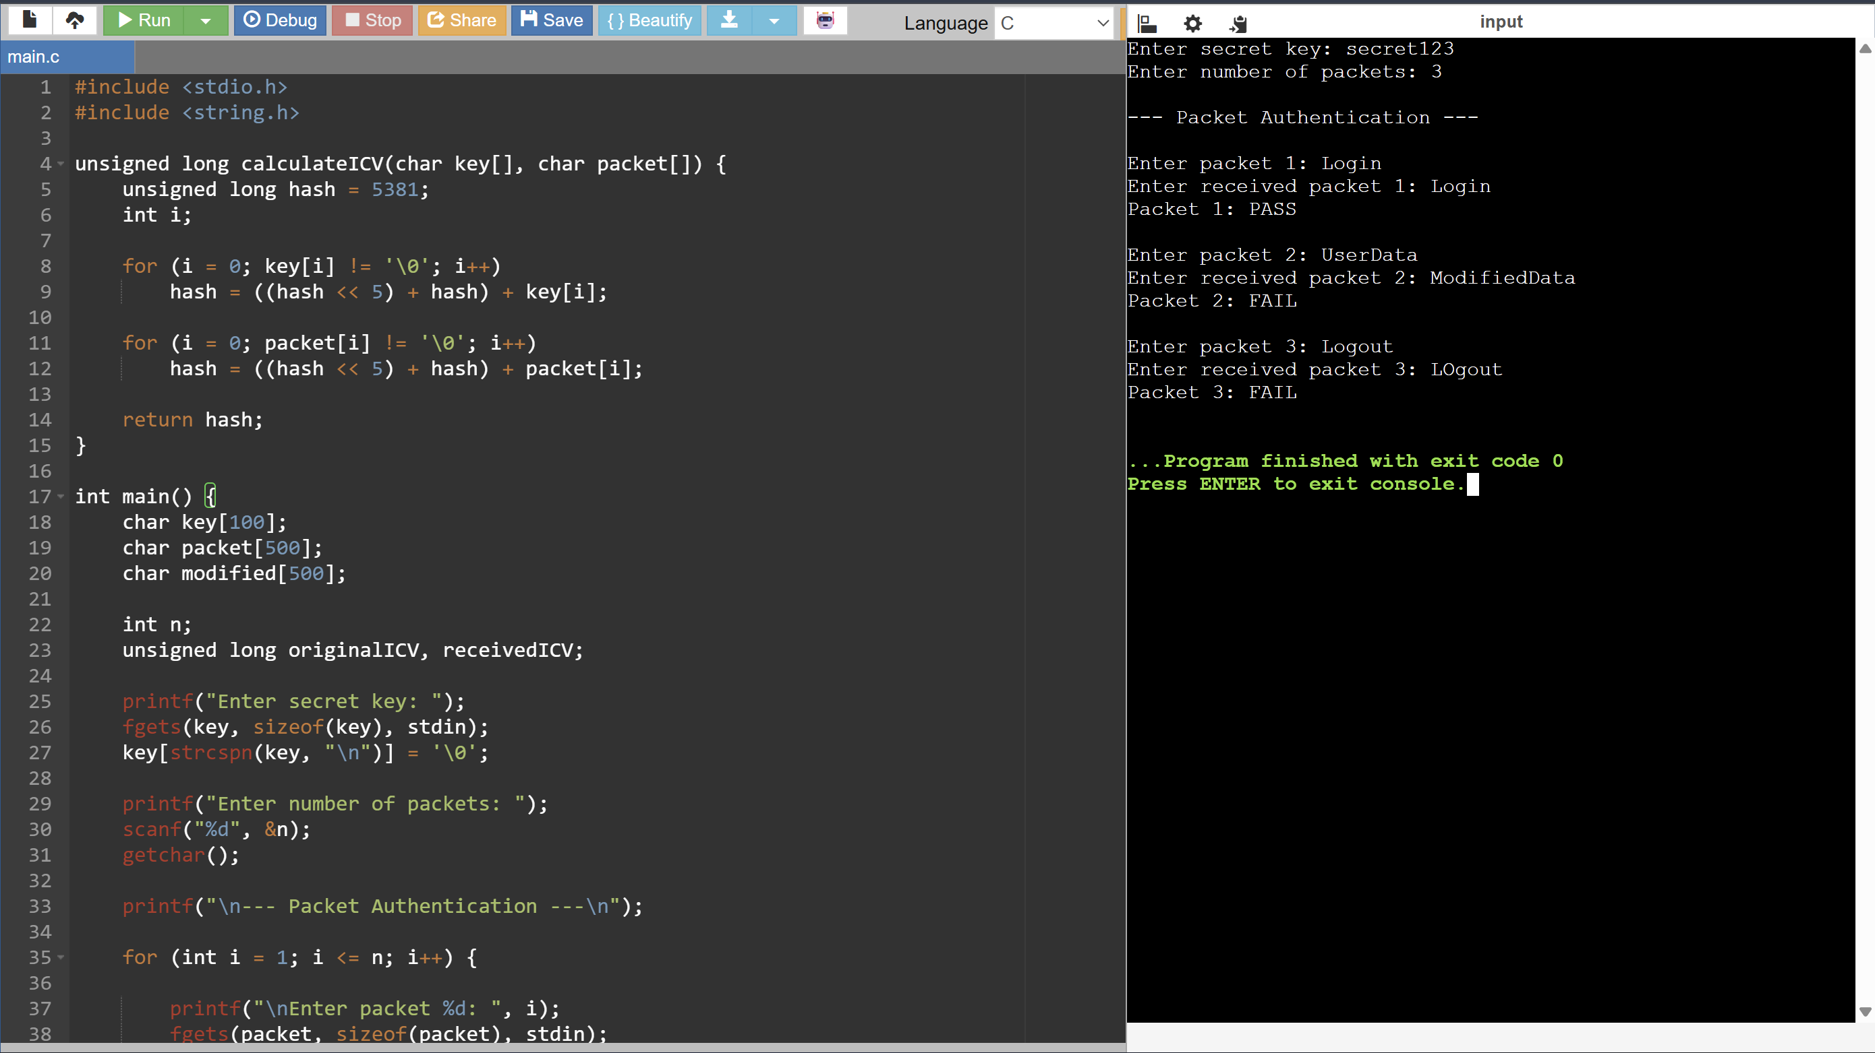

RUBRICS FOR CALCULATION:

Criteria | Weightage | Level 4 (Exemplary) | Level 3 (Proficient) | Level 2 (Developing) | Level 1 (Beginning)
Problem Understanding | 20% | Clearly understands problem constraints, edge cases, and competitive requirements | Understands problem with minor gaps in constraints | Partial understanding; misses key constraints | Misinterprets problem or constraints
Algorithm | 25% | Selects optimal algorithm with best time and space complexity for competitive constraints | Uses efficient algorithm with minor scope for improvement | Uses basic/inefficient approach | No clear algorithmic approach
Code Implementation | 20% | Writes correct, efficient, and clean code that passes all constraints | Code works with minor errors or inefficiencies | Partially correct code; fails for some cases | Code does not execute or gives incorrect results
Competitive Performance | 20% | Solves problem within time limits and handles large inputs effectively | Solves within acceptable time with minor delays | Struggles with time limits or larger inputs | Unable to solve within time constraints
Test Case Handling | 15% | Handles all test cases including edge and hidden cases | Handles most test cases | Misses important edge cases | Fails on multiple test cases

